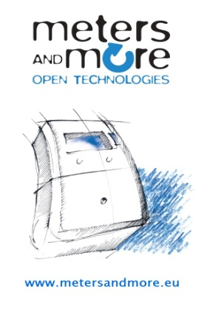
Meters and More at the European Utility Week 2014

BEYOND THE METER: A LEADING,
OPEN SOLUTION FOR SMART METERING

Brussels (Belgium), November 28th, 2014 - The no profit Association Meters and More, participated at the 2014 edition of the European Utility Week, Europe’s biggest smart utility event which took place from the 4th to the 6th of November in Amsterdam, at the Exhibition and Convention Centre RAI. As in the last 4 years, the Association contributed as silver sponsor gaining even more attention of customers and stakeholders interested in smart metering.

On November 5th, Meters and More gave a conference on smart metering solutions. Two members of the Board of Directors, Simone Chiappi and Alessandro Bertani presented smart solutions “Beyond the Meter”, sharing background information on the Association, explaining the new interfaces from the smart grid, the meter to home communication and the smart public lighting management system and finally suggesting new opportunities on the use of PLC in smart grids. Full interaction was guaranteed between the speakers and the public.

The conference was a great success, testifying the growing interest towards our activities. This was certainly a consequence of the positive result of vote on our standardization activities received in the CENELEC National Committees last October. Thanks to this result, Meters and More is now a Technical Specification of CENELEC (CLC/FPrTS 50568). This is an official acknowledgment of the value of Meters and More technology and it represents an opportunity for members and potential members for large scale deployment in the market.

As in the past years, Meters and More received many people at the stand, most of them showing interest on M&M’s recent standardization activities and expressing interest in becoming new members.

Meters and More Association is constantly growing and now it counts more than 45 members worldwide, leading stakeholders, utilities, manufacturers and institutions representing the entire smart grid value chain, all committed for the implementation of interoperable and open smart grid systems.

This shows the importance for cooperation among stakeholders in creating a sustainable energy future through innovation and new smart metering technology.

http://spintelligentpublishing.com/Digital/Metering-International/issue4-2014/files/63.html - search for page 38

